Power BI Custom Visual Step by Step

Step 1 Installation

<1> NodeJS

Can be download and installed from https://nodejs.org/en/

It can help us with the package management.

<2> Power BI Visual Tools

Open commend line and input :



<3> To check whether the power bi visual tools installed successfully, input :



If you see the following text, that means you have installed the visual tools successfully

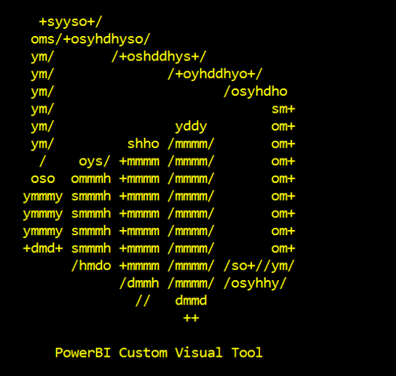

<4> Adding certificate for localhost:

1. input pbiviz --install-cert



b. place the certificate under Trusted Root Certificate Authorities

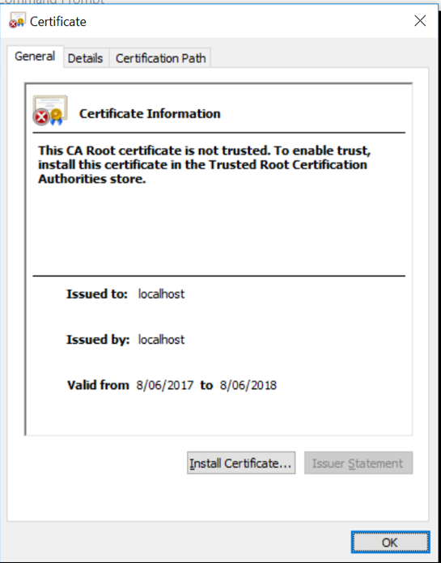 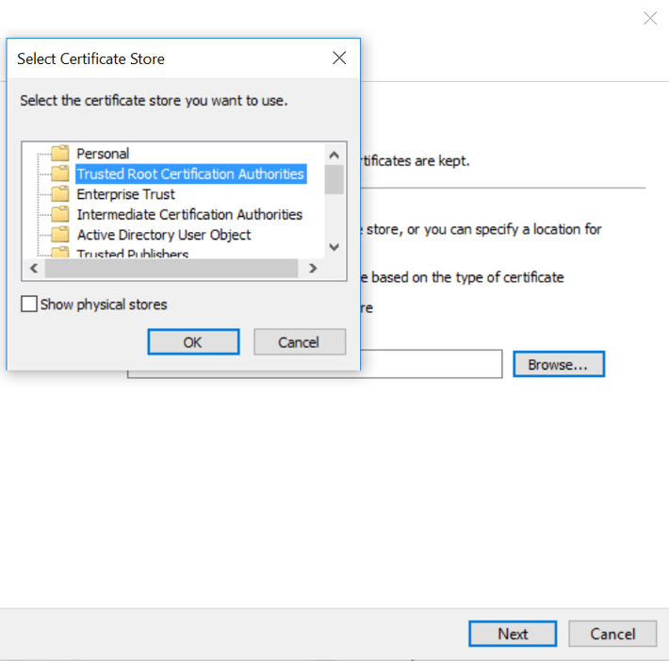

<5> Go to app.powerbi.com and login

1. go to settings(the gear icon), select "Setting" from the dropdown list

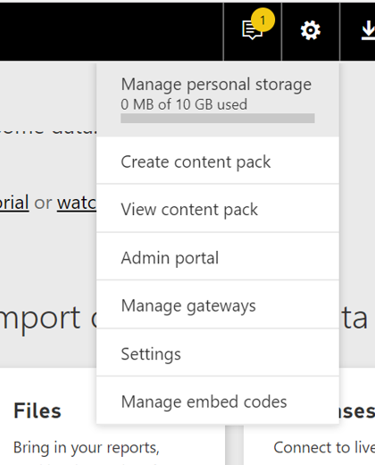

1. go to developer, and tick Enable developer visual for testing

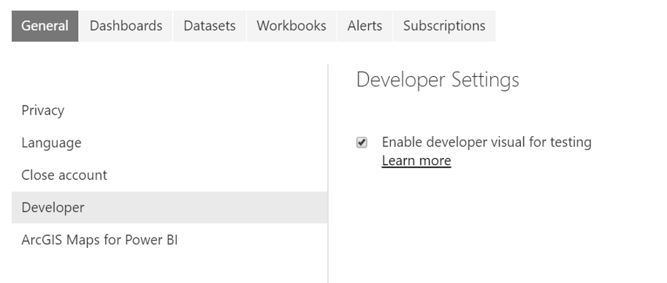

<6> Create a custome visual by input:

pbiviz new <customer visual name>

<customer visual name> should be the name you want to give to your custom visual

For example 

<7> Start the server by input:

pbiviz start

<8> Go to app.powerbi.com and select  from visualization section.

Then you should be able to see:

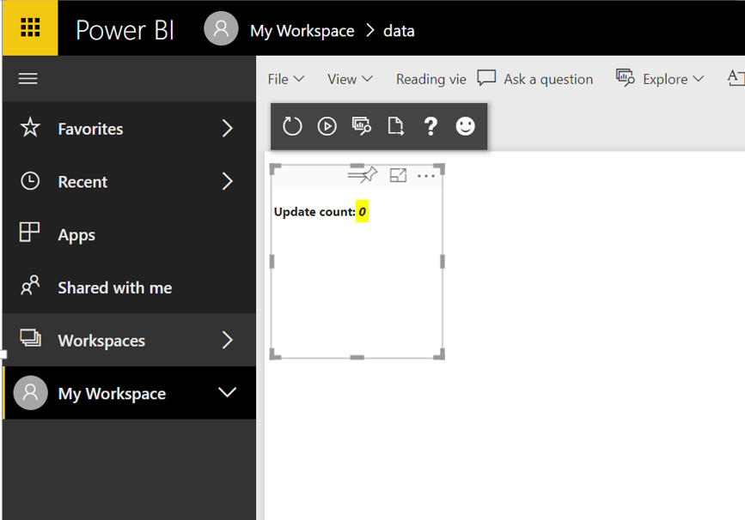

This means our custom visual works!